# Safety Warnings

THE MICRO:BIT IS AN EXPOSED BOARD, TO BE USED WITH CARE PLEASE RETAIN THIS INFORMATION FOR FUTURE REFERENCE. You can read the detailed document at - <http://microbit.org/guide/safety-advice/>

# General Safety Warnings

Using the BBC micro:bit is easy to use but is designed to have all the electrical parts on display. This does mean there's a small risk that the parts can be damaged and even overheat with a risk of injury but a little bit of care and caution will ensure you and your micro:bit will stay fit and healthy.



1. Always keep your BBC micro:bit in the anti-static bag when not in use. It's good practice for students to earth themselves before handling it.
2. Please handle your BBC micro:bit by its edges. This minimises the risk of damage through an electrostatic discharge.
3. Please use the battery pack and the USB lead provided to power your micro:bit. Do not use portable battery chargers or USB charging ports (often marked with a lightning bolt or 'SS'), to power your micro:bit. Using these may damage your micro:bit and stop it working properly.
4. Please avoid handling the BBC micro:bit circuit board while plugged into a power supply.
5. All peripherals (for example: USB cable, battery holder, sensors) used with your BBC micro:bit should comply with the relevant standards and should be marked accordingly.
6. Connecting your BBC micro:bit to any unapproved peripherals could damage your BBC micro:bit
7. Please do not attempt to keep using faulty micro:bits. If a school-issued micro:bit develops a fault, contact the vendor immediately.
8. The maximum current safely supplied to an external circuit using the 3V pin on the edge connector is 100mA. Please make sure this limit is not exceeded.
9. Please do not store or use your BBC micro:bit in extremely hot or cold environments.
10. Do not place any metal objects across the printed circuits on the board as this can cause a short circuit damaging your BBC micro:bit. This can cause risk of burn or fire.
11. Do not use your BBC micro:bit in water or with wet hands.
12. Do not leave your BBC micro:bit plugged into a computer or any other device unsupervised.
13. Please do not leave your BBC micro:bit within reach of children under 8 years of age.
14. Please operate your BBC micro:bit in a well ventilated room To remove the battery pack, pinch the connector with your fingers. Do not remove by pulling the wires.

# Battery Warnings



1. Do not try to charge normal (non-rechargeable) batteries
2. Please do not mix different types of batteries or mix new and used batteries.
3. Please use batteries of the same or equivalent type as those recommended.
4. Please insert batteries the correct way round (with the correct polarity).
5. Please remove spent batteries from the battery holder.
6. Do not short-circuit the battery supply terminals, for example by placing a metal object across the terminals.
7. Only use Zinc or Alkaline batteries with your BBC micro:bit.
8. Please do not use rechargeable batteries

# BBC micro:bit – A Short Introduction

The text on this page is a copy of the content from <https://microbit.org/guide/hardware/pins/>. All rights to the content in section 2 of this document are owned by the micro:bit educational foundation.

The BBC micro:bit has 25 external connections on the edge connector of the board, which we refer to as ‘pins’. The edge connector is the grey area on the right side of the figure above. There are five large pins that are also connected to holes in the board labelled: 0, 1, 2, 3V, and GND. And along the same edge, there are 20 small pins that you can use when plugging the BBC micro:bit into an edge connector.

# micro:bit Pin Diagram

**Large pins -** You can easily attach crocodile clips or 4mm banana plugs to the five large pins.

The first three, labelled 0, 1 and 2 are flexible and can be used for many different things - which means they are often called ‘general purpose input and output’ (shortened to GPIO). These three pins also have the ability to read analogue voltages using something called an analogue-to-digital converter (ADC). They all have the same function:

* **0**: GPIO (general purpose digital input and output) with analogue to digital convertor (ADC).
* **1**: GPIO with ADC
* **2**: GPIO with ADC

The other two large pins (3V and GND) are very different! The pins labelled 3V and GND relate to the power supply of the board, and they should NEVER be connected together.

If the BBC micro:bit is powered by USB or a battery, then you can use the 3V pin as a *power output* to power peripherals with.

**3V**: *3 volt power output* or *power input*. (1) *power output*: If the BBC micro:bit is powered by USB or a battery, then you can use the 3V pin as a power output to power peripherals with; (2) *power input*: If the BBC micro:bit is not being powered by USB or battery, you can use the 3V pin as a power input to power the BBC micro:bit

**GND**: attaches to ground in order to complete a circuit (required when using the 3V pin)

If you hold the ‘GND’ pin with one hand, you can program the BBC microbit to detect yourself touching the 0,1 or 2 pins with your other hand, giving you three more buttons to experiment with (you just used your body to complete an electrical circuit).

**Small pins -** There are 20 small pins numbered sequentially from 3-22 (these pins are not labeled on the BBC micro:bit, however, they are labelled in the picture above).

Unlike the three large pins that are dedicated to being used for external connections, some of the small pins are shared with other components on the BBC micro:bit board. For example, pin 3 is shared with some of the LEDs on the screen of the BBC micro:bit, so if you are using the screen to scroll messages, you can’t use this pin as well.

* **pin 3**: GPIO shared with LED Col 1 of the LED screen; can be used for ADC and digital I/O when the LED screen is turned off.
* **pin 4**: GPIO shared with LED Col 2 of the LED screen; can be used for ADC and digital I/O when the LED screen is turned off.
* **pin 5**: GPIO shared with Button A. This lets you trigger or detect a button "A" click externally. This pin has a pull-up resistor, which means that by default it is at voltage of 3V. To replace button A on the BBC micro:bit with an external button, connect one end of the external button to pin 5 and the other end to GND. When the button is pressed, the voltage on pin 5 is pulled down to 0, which generates a button click event.
* **pin 6**: GPIO shared with LED Col 9 of the LED screen; can be used for digital I/O when the LED screen is turned off.
* **pin 7**: GPIO shared with LED Col 8 of the LED screen; can be used for digital I/O when the LED screen is turned off.
* **pin 8**: Dedicated GPIO, for sending and sensing digital signals.
* **pin 9**: GPIO shared with LED Col 7 of the LED screen; can be used for digital I/O when the LED screen is turned off.
* **pin 10**: GPIO shared with LED Col 3 of the LED screen; can be used for ADC and digital I/O when the LED screen is turned off.
* **pin 11**: GPIO shared with Button B. This lets you trigger or detect a button “B” click externally.
* **pin 12**: Dedicated GPIO, for sending and sensing digital signals.
* **pin 13**: GPIO that is conventionally used for the serial clock (SCK) signal of the 3-wire Serial Peripheral Interface (SPI) bus.
* **pin 14**: GPIO that is conventionally used for the Master In Slave Out (MISO) signal of the SPI bus.
* **pin 15**: GPIO that is conventionally used for the Master Out Slave In (MOSI) signal of the SPI bus.
* **pin 16**: Dedicated GPIO (conventionally also used for SPI ‘Chip Select’ function).
* **pins 17 and 18**: these pins are wired to the 3V supply, like the large ‘3V’ pad.
* **pins 19 and 20**: implement the clock signal (SCL) and data line (SDA) of the I2C bus communication protocol. With I2C, several devices can be connected on the same bus and send/read messages to and from the CPU. Internally, the accelerometer and the compass are connected to i2c.
* **pins 21 and 22**: these pins are wired to the GND pin and serve no other function

# Pre-requisites

If you need assistance with the assembly of the micro:bit, Edge connector breakout board, mounting board and the breadboard please speak to one of the volunteers on duty.

To be able to perform this tutorial you will need the following components –

1. Parts required –
   1. 1 x BBC Micro:bit
   2. 1 x Mounting Plate
   3. 1 x Edge connector breakout board
   4. 1 x Bread board
   5. 1 x 10K (10,000) Ohm Resistor
   6. 3 x Male – Female Dupont wires
   7. 2 x Male – Male Dupont wires
   8. 1 x LDR
2. Assembly required –
   1. Bread board mounted on top of the mounting plate
   2. BBC Micro:bit inserted into the Edge Connector breakout board

# C:\Perf\Personal\Github\CoderDojo\Images\Hi_Res_BBC_Microbit.jpg

Before proceeding please check your setup and confirm that all the required parts are configured as demonstrated in the above picture.

# Learning Objectives

The objectives of this tutorial are to introduce the reader to the working of an LDR or Light Dependant Resistor, learn to build simple circuits using the LDR and most importantly understand how to read the current state of the LDR (resistance being provided). We will write code in this tutorial to read the value of the LDR and present the value to the micro:bit LED display.

This tutorial builds upon concepts introduced in previous tutorials so please make sure you have covered the previous tutorials before you dive into this one.

Explore the following concepts through making –

1. Connecting elements in a circuit
2. Understanding the flow of current through the elements in the circuit
3. Understanding the concepts of voltage across different components in a circuit
4. Understanding the concept of elements connected in series and parallel in a circuit
5. Understand what is an LDR or Light Dependant Resistor
6. Understand how to connect an LDR to a circuit
7. Understand how to read values of the LDR and write to the LED display on the micro:bit

# Exploring components

If you haven’t been introduced to the following components it’s worth reading through this section –

1. Resistors
2. LED’s
3. NPN/PNP Bi-Junction Transistors or also called BJT’s
4. RGB LED’s
5. Potentiometer
6. LDR or Light Dependant Resistor

Let’s briefly look at what resistors and LED’s are all about before we dive into actually making the circuit.

# What Are Resistors

*“What is a resistor?” the student asked.  
“It’s a component that resists the flow of current” I said.  
“Hmm.. I don’t get it. What does it do to my circuit?” the student asked.  
“Well, it doesn’t actually do anything actively, all a resistor does is resists the flow of current through a given circuit” I said. Have a look at what the resistor might look like.*

Resistors are electronic components which have a specific, never-changing [electrical resistance](https://learn.sparkfun.com/voltage-current-resistance-and-ohms-law/resistance). The resistor’s resistance limits the flow of electrons through a circuit. They are passive components, meaning they only consume power (and can’t generate it). Resistors are usually added to circuits where they complement active components like op-amps, microcontrollers, and other [integrated circuits](https://learn.sparkfun.com/tutorials/integrated-circuits). Commonly resistors are used to limit current, [divide voltages](https://learn.sparkfun.com/tutorials/voltage-dividers), and [pull-up I/O lines](https://learn.sparkfun.com/tutorials/pull-up-resistors).



The schematic symbol used for resistors in circuits is –



# What Are LED’s

LEDs are so common, they come in dozens of different shapes and sizes. The LEDs you are most likely to use are the through hole LEDs with two legs. There are lots of LEDs that are small and hard to solder but these are easy to use with a breadboard because they have long wires we can stick in. The clear or clearish bulb is what protects the light emitter (that’s where the magic happens). In fact, the first two letters of LED stand for Light Emitting.

A really nice thing about LEDs is that they are very simple. Unlike some chips that have dozens of pins with names and special uses, LEDs have only two wires. One wire is the anode (positive) and another is the cathode (negative). The two wires have different names because LEDs only work in one direction and we need to keep track of which pin is which. One goes to the positive voltage and the other goes to the negative voltage. Electronic parts that only work in 'one direction' like this are called Diodes, that’s what the last letter of LED stands for.

[](https://learn.adafruit.com/assets/3890)

* The longer lead goes to the more-positive voltage
* Current goes in one direction, from the anode (positive) to the cathode (negative)
* LEDs that are 'backwards' won't work - but they won't break either

The schematic representation for LED’s in circuits is as follows –



It's all a little confusing - we often have to think about which is which. So to make it easy, there's only one thing you need to remember and that's the LED wont light up if you put it in backwards. If you're ever having LED problems where they are not lighting, just flip it around. Its very hard to damage an LED by putting it in backwards so don't be scared if you do



One of the best things about modern LEDs is all the colors they come in. It used to be that LEDs were only red or maybe yellow and orange, which is why early electronics from the 70s and 80s only had red LEDs. The color emitted from an LED has to do with what type of material they are made of. So red, for example, is made with Gallium Arsenide. Since then, scientists have experimented with many other materials and figured out how to make other colors such as green and blue, as well as violet and white.

# What Are Bi-Polar Junction Transistor or BJT’s

Transistors make our electronics world go ‘round. They’re critical as a control source in just about every modern circuit. Sometimes you see them, but more-often-than-not they’re hidden deep within the die of an integrated circuit. In this tutorial we’ll introduce you to the basics of the most common transistor around: the bi-polar junction transistor (BJT). In small, discrete quantities, transistors can be used to create simple electronic switches, digital logic, and signal amplifying circuits. In quantities of thousands, millions, and even billions, transistors are interconnected and embedded into tiny chips to create computer memories, microprocessors, and other complex ICs.



There are two types of basic transistor out there: bi-polar junction (BJT) and metal-oxide field-effect (MOSFET). In our tutorials we’ll focus on the BJT, because it’s slightly easier to understand and work with. Digging even deeper into transistor types, there are actually two versions of the BJT: NPN and PNP. We’ll turn our focus even sharper by limiting our early discussion to the NPN. By narrowing our focus down – getting a solid understanding of the NPN – it’ll be easier to understand the PNP (or MOSFETS, even) by comparing how it differs from the NPN.

Transistors are fundamentally three-terminal devices. On a bi-polar junction transistor (BJT), those pins are labelled collector (C), base (B), and emitter (E). The circuit symbols for both the NPN and PNP BJT are below:



The only difference between an NPN and PNP is the direction of the arrow on the emitter. The arrow on an NPN points out, and on the PNP it points in. Transistors are built by stacking three different layers of semiconductor material together. Some of those layers have extra electrons added to them (a process called “doping”), and others have electrons removed (doped with “holes” – the absence of electrons). A semiconductor material with extra electrons is called an n-type (n for negative because electrons have a negative charge) and a material with electrons removed is called a p-type (for positive). Transistors are created by either stacking an n on top of a p on top of an n, or p over n over p. See the diagram below -



Simplified diagram of the structure of an NPN. Notice the origin of any acronyms?



With some hand waving, we can say electrons can easily flow from n regions to p regions, as long as they have a little force (voltage) to push them. But flowing from a p region to an n region is really hard (requires a lot of voltage). But the special thing about a transistor – the part that makes our two-diode model obsolete – is the fact that electrons can easily flow from the p-type base to the n-type collector as long as the base-emitter junction is forward biased (meaning the base is at a higher voltage than the emitter).

The NPN transistor is designed to pass electrons from the emitter to the collector (so conventional current flows from collector to emitter). The emitter “emits” electrons into the base, which controls the number of electrons the emitter emits. Most of the electrons emitted are “collected” by the collector, which sends them along to the next part of the circuit. A PNP works in a same but opposite fashion. The base still controls current flow, but that current flows in the opposite direction – from emitter to collector. Instead of electrons, the emitter emits “holes” (a conceptual absence of electrons) which are collected by the collector.

The transistor is kind of like an electron valve. The base pin is like a handle you might adjust to allow more or less electrons to flow from emitter to collector.

# What Are RGB LED’s

An RGB LED is a combination of 3 LEDs in just one package:

* 1x Red LED
* 1x Green LED
* 1x Blue LED

The color produced by the RGB LED is a combination of the colors of each one of these three LEDs. An RGB LED looks like this:

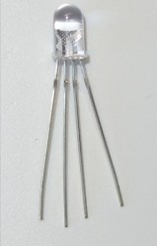

There are common anode RGB LEDs and common cathode RGB LEDs. We will be using common cathode LED’s for most of our experiments in this class. See figure below:

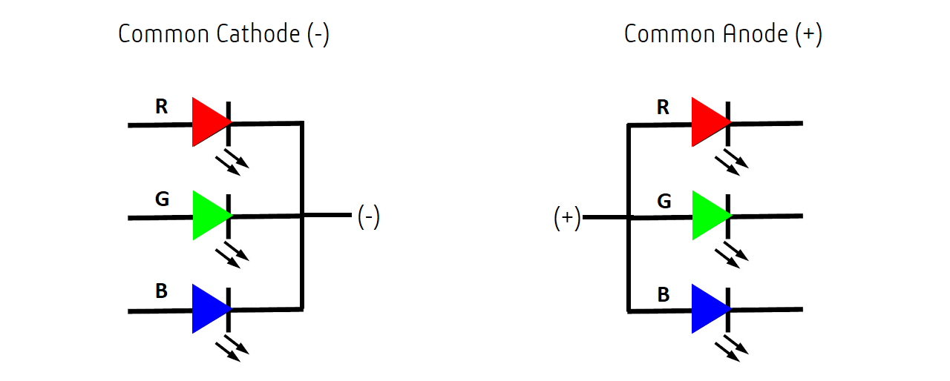

As you can see, the 3 LEDs can share the cathode or the anode. This results in an RGB LED that has 4 pins, one for each LED, and one common cathode or one common anode. The common anode RGB LED is the most popular type. Using an RGB LED you can create one of those three colours – red, green or blue – by activating just one LED. For example, if you want to produce blue, you activate the blue LED and turn off the other two. To produce other colours, you can combine the three colours in different intensities.

**Mixing Colours -** To generate different colours you can use PWM to adjust the brightness of each LED. As the LEDs are very close to each other, we can only see the final colours result rather than the three colours individually. To have an idea on how to combine the colours, take a look at the following chart. This is the simplest colour mixing chart, there are more complex colour charts on the web.

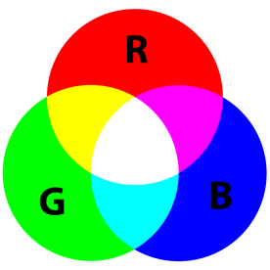

**RGB LED Pins** - RGB LEDs have 4 pins which can be distinguished by their length. The longest one is the ground (-) or voltage (+) depending if it is a common cathode or common anode LED, respectively. The other three legs correspond to red, green, and blue, as you can see in the figure below:

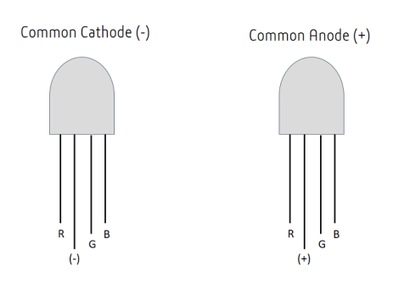

# What is a potentiometer

A potentiometer is a small sized electronic component whose resistance can be adjusted manually by turning the shaft of the potentiometer. Increasing or decreasing the value of resistance controls the amount of current flowing in a circuit. The potentiometer is used in various electronics, for example: is used as volume knob in music systems, as fan regulators etc. Potentiometer has two strips made on it resistive and conductive.

The resistive strip is made of carbon and is responsible for potentiometer’s resistance variance feature. The conductive strip helps the potentiometer to carry the current into the circuit in accordance with the resistance. To understand the theory of our humble potentiometers (or pots), let us know the parts of the potentiometer:

* Lugs: Potentiometers by convention have three lugs. They are numbered 1, 2, and 3 as shown in the figure.
* Shaft: This is a plastic/metallic stick which is used to turn the potentiometer.
* Resistive Strip: This is the heart of the potentiometer. It is a carbon strip that is printed on a phenolic strip. There are metal contacts in the end to connect it to the lugs.
* Metal Wiper: When we rotate the shaft, it in turn rotates a metallic wiper which connects the lug 1 and lug2.

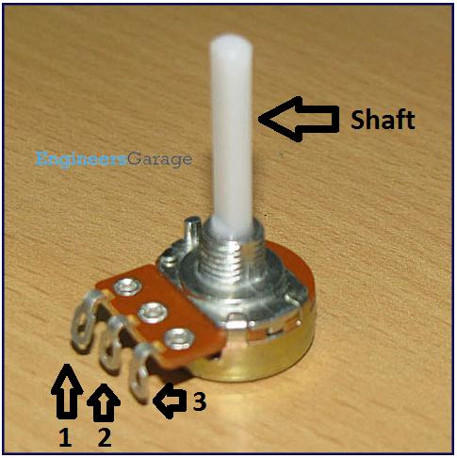

The circuit symbol for the potentiometer is as follows -

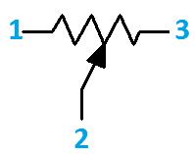

# What is an LDR (Light Dependant Resistor)

A photoresistor (or light-dependent resistor, LDR, or photo-conductive cell) is a light-controlled variable [resistor](https://en.wikipedia.org/wiki/Resistor). The [resistance](https://en.wikipedia.org/wiki/Electrical_resistance) of a photoresistor decreases with increasing incident light intensity; in other words, it exhibits [photoconductivity](https://en.wikipedia.org/wiki/Photoconductivity). A photoresistor can be applied in light-sensitive detector circuits, and light-activated and dark-activated switching circuits.

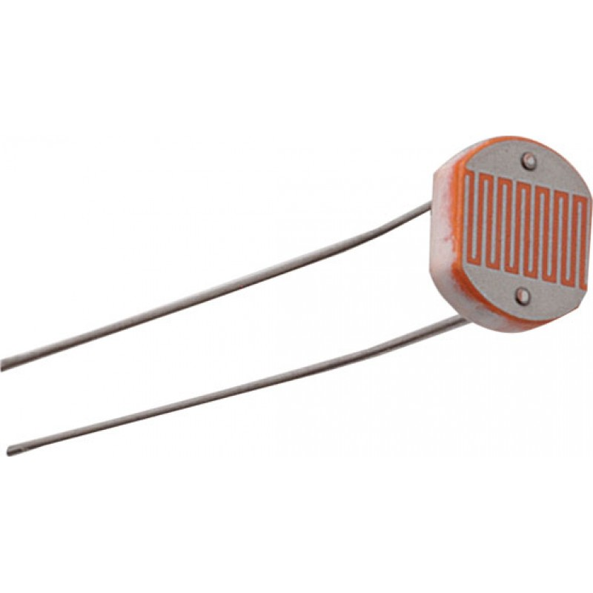

A photoresistor is made of a high resistance [semiconductor](https://en.wikipedia.org/wiki/Semiconductor). In the dark, a photoresistor can have a resistance as high as several megohms (MΩ), while in the light, a photoresistor can have a resistance as low as a few hundred ohms. If incident light on a photoresistor exceeds a certain [frequency](https://en.wikipedia.org/wiki/Frequency), [photons](https://en.wikipedia.org/wiki/Photon) absorbed by the semiconductor give bound [electrons](https://en.wikipedia.org/wiki/Electron) enough energy to jump into the [conduction band](https://en.wikipedia.org/wiki/Conduction_band).

The resulting free electrons (and their [hole](https://en.wikipedia.org/wiki/Electron_hole) partners) conduct electricity, thereby lowering [resistance](https://en.wikipedia.org/wiki/Electrical_resistance). The resistance range and sensitivity of a photoresistor can substantially differ among dissimilar devices. Moreover, unique photoresistors may react substantially differently to photons within certain wavelength bands. The circuit symbol for the LDR is provided below.

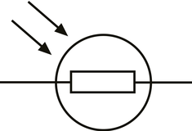

Light dependent resistors come in different shapes and colors. LDRs are very useful in many electronic circuits, especially in alarms, switching devices, clocks, street lights and more. There are some audio application uses such as audio limiters or compressors. It is used to turn ON or OFF a device according to the ambient light.

# Activity

Before we get started, let’s make sure that all the required components are configured as required.

# Step 1 - Build

Let’s now connect up the relevant components on our micro:bit.

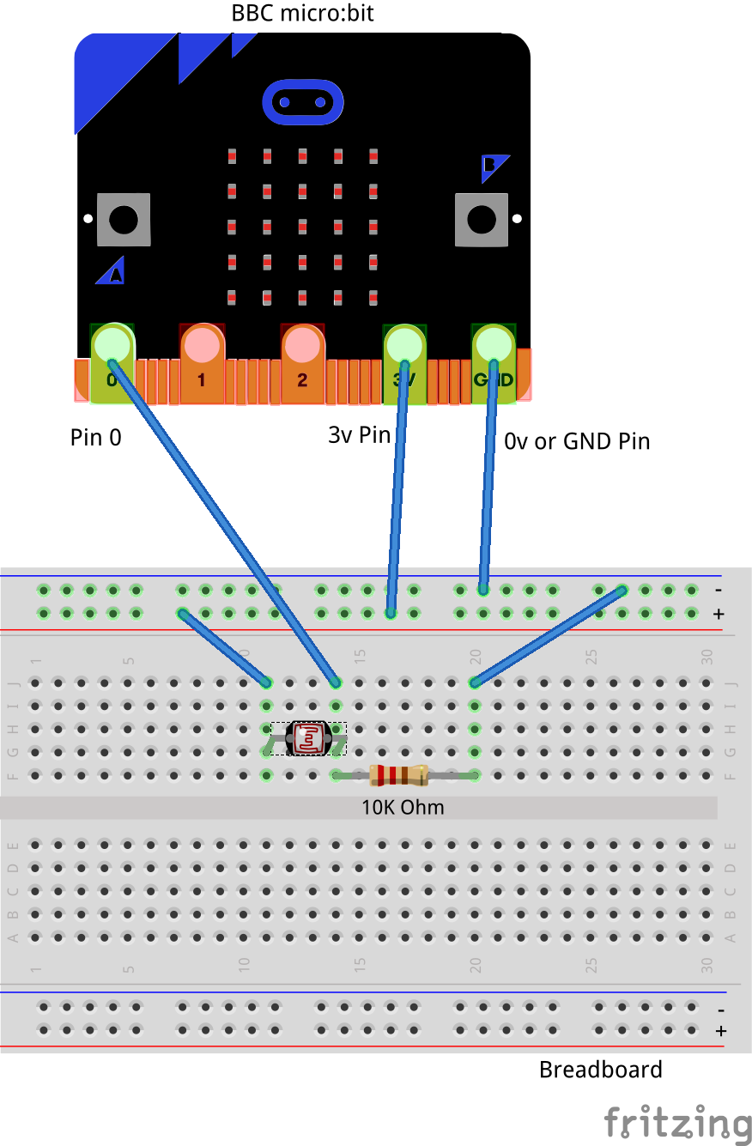

Please note that on the breadboard, between the horizontal blue and red lines all the holes are horizontally connected to each other. In the middle of the board however all the holes are vertically connected to each other. In in doubt please speak to a volunteer/mentor to clarify the approach.

The connections should be made as follows:

1. Connect the Male – Female Dupont wire from the Ground (0v) pin on the micro:bit (using the Edge Connector Breakout board) to the ground rail on the breadboard.
2. Connect a Male – Female Dupont wire from Pin 0 on the micro:bit to the first 2.2K Ohm resistor. Connect the 2.2K Ohm resistor to the Red pin of the RGB LED.
3. Connect a Male – Female Dupont wire from Pin 1 on the micro:bit to the second 2.2K Ohm resistor. Connect the 2.2K Ohm resistor to the Blue pin of the RGB LED.
4. Connect a Male – Female Dupont wire from Pin 2 on the micro:bit to the third 2.2K Ohm resistor. Connect the 2.2K Ohm resistor to the Green pin of the RGB LED.
5. Connect the Cathode (Negative, Longest leg) of the LED to the Ground (0v) using a Male to Male Dupont cable.
6. Connect a Male – Female Dupont wire from Pin 10 of the micro:bit to the middle pin of the potentiometer.
7. Connect a Female to Female Dupont wire from the Ground terminal of the breadboard to the ground terminal of the potentiometer.
8. Connect a Female to Female Dupont wire from the 3v terminal of the breadboard to the 3v terminal of the potentiometer
9. Connect a Female to Male Dupont wire from Pin 16 on the micro:bit to a 10K Ohm resistor. Then connect the other end of the resistor to one end of the push button switch. Connect the other end of the push button switch to the ground rail of the breadboard.

This simple circuit builds upon the concepts we have learned in previous tutorials and introduces you to new concepts. The main difference among this circuit and the other LED circuits we have built before is the use of a four pin LED as compared to a two pin LED. The concepts however remain the same, requiring use of a current limiting resistor connected between the positive and LED including the other terminal (Common Cathode in our case) being grounded.

You can use the RGB LED to create thousands of different colours by mixing up different tones of Red, Blue and Green. This is achieved by lighting up each of the LED i.e. Red, Blue, Green, components independently and mixing the fundamentals colours Red, Blue, Green to obtain new colours.

One new aspect to this tutorial is the introduction of a push button switch which we will read to work out if we should read the current value of the potentiometer.

* In this example we will write code to read the state of the switch
* If the state of the switch is on then we will read the current value of the signal from the potentiometer.
* This voltage being read from the potentiometer will vary between 0 – 3v and will be read using the “analog read pin P0” command on the micro:bit.
* The resulting value of read by the micro:bit will be between 0 (equivalent to 0v) and 1023 (equivalent to 3v).
* If the value of the potentiometer is < 512 we will turn off the Red, Green, Blue LED
* While if the read value of the potentiometer is > 512 we will turn on the Red, Green. Blue LED in sequence.

We will add to the code from the previous tutorial.

## Self-Assessment

* I have the breadboard mounted onto the mounting plate.
* I have the micro:bit plugged into the Edge connector breakout board.
* I understand each of the components in the circuit i.e. LED, resistor, Male – Female Dupont wires, etc.
* I have each of the elements in the circuit wired up using the breadboard
* I have checked the connections on the circuit and have not powered it on
* I understand how to use the male – male and male – female dupont cables to create connections using the breadboard
* I understand what the positive / 3v and ground / 0v rails (top and bottom) of the breadboard do and how they are connected
* I understand how the central rows in the breadboard are lined up together and how they are connected.
* I understand the difference between 3 Volt (3V) and Ground (0 Volt of 0V)
* I understand the need for a current limiting resistor used in series between the supply and the LED.
* I understand the differences between a Common Cathode and a Common Anode LED.
* I understand how to wire-up a Common Cathode LED for use in a general circuit.
* I understand how to wire up the potentiometer to the circuit for use with the micro:bit
* I understand how to wire up a push button switch using a pull down resistor

This now completes your circuit.

**PLEASE DO NOT POWER ON YOUR micro:bit UNLESS YOU HAVE HAD YOUR CIRCUIT VALIDATED BY A FACILITATOR/MENTOR/Volunteer.**

# Step 2 - Explore

Discuss the following concepts with the learning facilitator

1. Which components in this circuit are in series?
2. Are there any components in this circuit which are connected in parallel?
3. What are the paths for current flowing through this parallel circuit?
4. Which are passive and active components in a parallel circuit?
5. Any questions that I have with regards to the differences between a common cathode and a common anode RGB LED.
6. Is it possible to energize or light up just the Red, Blue or Green components of the RGB LED individually?
7. Is it possible to energize or light up all of the three elements i.e. Red, Blue and Green of the RGB LED simultaneously?
8. Are we reading the value from the potentiometer as a digital signal or an analog signal?
9. What do the minimum and maximum values of the analog signal represent in terms of voltages?
10. What is a push button switch and what are the different states of a push button switch?
11. How does a push button switch work?
12. Is the external push button switch different in functionality from the on-board push button switch

## Self-Assessment

* I can explain what a circuit means, what are components connected in series and components connected in parallel.
* I can explain the differences between active and passive components in circuits.
* I understand how components can be connected in series and parallel.
* I understand the use of the 2.2K resistor in the circuit to limit the current flowing into the RGB LED
* I understand the impact of having a resistor too large in value or too small in value in series with the Base of the transistor
* I understand the structure of a Common Cathode RGB LED and how it is setup on a breadboard
* I understand the structure of a Common Anode RGB LED and how it is setup on a breadboard
* I understand how to individually light up the Red, Blue or Green components of the LED
* I understand how to wire up the potentiometer into the circuit and connect up with the micro:bit
* I understand how to connect a push button switch using a pull down resistor to the micro:bit

# Step 3 – Validate

Please call a facilitator to check your circuit before you power it on. It is important that you get a learning facilitator/mentor/volunteer to check the connections on your circuit before powering it on.

Incorrect connections might result in a dead (bricked, burnt, short-circuited, etc.) Micro:bit requiring you to purchase another Micro:bit for $30 AUD.

# Step 4 – Power On

Awesome, you are almost at the point where you can power on your circuit and watch the magic un-fold. Please call a facilitator to check your circuit before you power it on. It is important that you get a learning facilitator to check the connections on your circuit before powering it on.

Once the learning facilitator has verified your circuit you should now proceed and power on the Micro:bit. If you have not had your learning facilitator verify the circuit PLEASE GO BACK To step 3 and have one of the learning facilitators verify your connections.

Powering on the Micro:bit requires that you connect the USB power cord for your Micro:bit (plugged into the Micro:bit board) into your laptop.

Incorrect connections might result in a dead (bricked, burnt, short-circuited, etc.) Micro:bit requiring you to purchase another Micro:bit for $30 AUD.

## Self-Assessment

* I have validated that the circuit is now wired correctly and safe to be powered on

# Let’s write some code

Now that we have put together the circuit it’s time to write some code and get the circuit working. So let’s head over to the micro:bit block code editor page (<https://makecode.microbit.org/>) and get coding!!!

In the following section we will dive into the code you will put together for this tutorial –

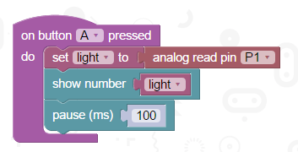

The code used in this tutorial is similar to the code we’ve written for our previous tutorials where we wrote code to automate the turning on and off of RGB LED. The additional difference here is the introduction of the switch which when pressed triggers reading the value of the analog signal generated by the potentiometer and storing it in the “potentiometer” variable. Depending on the value generated we either turn the LED’s on turn them off. You are encouraged to play around with the timings (pause command) and change the rate of blinking of the LEDs using code or even change the pins used to power on the LED and see if that makes any difference.

As mentioned before the aim of this tutorial is to create a software based switch i.e. writing commands in software and asking the micro:bit to turn the RGB LED on and off with the added complexity of sensing the strength of the analog signal generated by the potentiometer. We will extend the code written in the previous tutorial and create two sets of software switches with a difference i.e. listen for user input provided by a switch and then turn the LED’s on/off. Also by varying the “pause” time i.e. the amount of time we request the micro:bit to go to sleep we are able to create different types of lighting patterns.

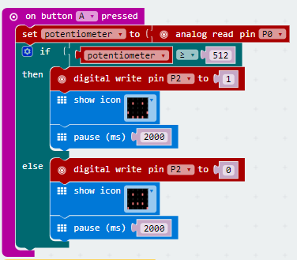

The software based switch involves the use of the following command, “digitial write pin2” and “digitial write pin1”. In the digital world computers only understand 0’s and 1’s. So if we were to turn on a pin i.e. to send a signal and switch on a particular pin on the micro:bit you have to send it a 1 and if we intended to turn off a pin i.e. send it a signal and switch off a particular pin on the micro:bit you would send it a 0.

In the first set of code that we write we’ll only focus on listening to user input provided on the external button and then depending on whether the button is on or off we’ll decide to read the value from the potentiometer. So let’s dive into the code and get started.

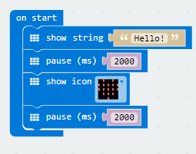

On start code block -

1. We display a welcome message to the user.
2. We pause for 2s. This essentially tells the micro:bit to go to sleep for 2s.
3. We then display a pattern using LED’s. You can change this to whatever you like.
4. Finally we have another set of pause commands so that people can appreciate the LED’s being lit up.
   * Not having the pause command will mean that the micro:bit (our little computer) still lights up the LED’s but does it so quickly that we just don’t get an opportunity to appreciate the work it’s done.
   * Similar to the work we’ve done in scratch we will inject pause statements (only where required) asking the computer to pause so that the human beings interacting with it can appreciate the transition from one mode of operation to another.
5. We finally pause a bit before continuing with rest of the code.

Forever Code block –

1. The first line of the block reads the state of Pin 16 to which the external push button switch is connected. If the push button is read as on (or pressed) then the remaining actions in the code block are performed.
2. The second line creates a variable called “potentiometer” and assigns it a value read from the current potentiometer setting using the “analog read pin” command. This reads the value of the analog signal from the potentiometer which can range between 0 – 1023 (0volt to 3volts)
3. Within the if block, the first line is an if statement which includes a test for the value of the signal read from the potentiometer. If this value is greater than 512 we want to light up the RGB LED else we want to turn the RGB LED off. You can change the value sent by the potentiometer by turning the knob of the potentiometer.
4. Within the if block, the next line now includes the “digital write pin2” command we discussed a bit earlier to turn on the LED by sending it a 1. This lights up the Green filament within with RGB LED. The RGB LED should now appear green in colour.
5. Similarly we use the “digital write pin1” and “digital write pin0” commands to turn on the other two filaments in the RGB LED.
6. The next line then pauses the code for 2 seconds. Just like in scratch the pause command is really important causes it gives the human beings time to see, understand and perceive what is happening. The computer doesn’t need any time as such and without the pause/sleep command it would have happily continued going about its business. The pause commands makes the transition from on to the off state visible to the individual working on the micro:bit.
7. Within the else block, the first line then uses the “digital write pin2” command again to turn the pin off by sending it a 0.
8. Similarly we use the “digital write pin1” and “digital write pin0” commands to turn off the other two filaments in the RGB LED.
9. The next line clears up the LED’s and displays nothing on the screen giving it the illusion of the screen turning off creating a flashing on/off effect.
10. The final line of the simply pauses the entire code block for 2 seconds. Just like in scratch the pause command is really important causes it gives the human beings time to see, understand and perceive what is happening. The computer doesn’t need any time as such and without the pause/sleep command it would have happily continued going about it’s business. The pause commands makes the transition from on to the off state visible to the individual working on the micro:bit.

The code for the remaining blocks is similar to the ones from the previous tutorial.

On Button A Pressed block –

1. The On Button B pressed code block on the bbc micro:bit is designed to run code only when the user ever presses the Button B on the micro:bit.
2. The first line creates a variable called “potentiometer” and assigns it a value read from the current potentiometer setting using the “analog read pin” command. This reads the value of the analog signal from the potentiometer which can range between 0 – 1023 (0volt to 3volts)
3. Within the if block, the first line is an if statement which includes a test for the value of the signal read from the potentiometer. If this value is greater than 512 we want to light up the RGB LED else we want to turn the RGB LED off.
4. Within the if block, the next line now includes the “digital write pin2” command we discussed a bit earlier to turn on the LED by sending it a 1. This lights up the Green filament within with RGB LED. The RGB LED should now appear green in colour.
5. The third line then pauses the code for 2 seconds. Just like in scratch the pause command is really important causes it gives the human beings time to see, understand and perceive what is happening. The computer doesn’t need any time as such and without the pause/sleep command it would have happily continued going about its business. The pause commands makes the transition from on to the off state visible to the individual working on the micro:bit.
6. Within the else block, the first line then uses the “digital write pin2” command again to turn the pin off by sending it a 0.
7. The fifth line clears up the LED’s and displays nothing on the screen giving it the illusion of the screen turning off creating a flashing on/off effect.
8. The sixth line of the simply pauses the entire code block for 2 seconds. Just like in scratch the pause command is really important causes it gives the human beings time to see, understand and perceive what is happening. The computer doesn’t need any time as such and without the pause/sleep command it would have happily continued going about it’s business. The pause commands makes the transition from on to the off state visible to the individual working on the micro:bit.

The previous code blocks gave us the capability to look for pressing of button B and then performing a given set of actions. In the coding blocks below we introduce the use of code to monitor for button A being pressed and performing similar set of actions. The different here now is that button A provides a signed on Pin 1 which drives the blue filament on the RGB LED.

On Button B Pressed block –

1. The On Button B pressed code block on the bbc micro:bit is designed to run code only when the user ever presses the Button B on the micro:bit.
2. The first line creates a variable called “potentiometer” and assigns it a value read from the current potentiometer setting using the “analog read pin” command. This reads the value of the analog signal from the potentiometer which can range between 0 – 1023 (0volt to 3volts)
3. Within the if block, the first line now includes the “digital write pin1” command we discussed a bit earlier to turn on the LED by sending it a 1
4. We then light up the Blue LED filament of the RGB LED. You should now see the RGB light up as a blue LED.
5. The third line then pauses the code for 2 seconds. Just like in scratch the pause command is really important causes it gives the human beings time to see, understand and perceive what is happening.
   * The computer doesn’t need any time as such and without the pause/sleep command it would have happily continued going about its business.
   * The pause commands makes the transition from on to the off state visible to the individual working on the micro:bit.
6. Within the else block, the first line then uses the “digital write pin1” command again to turn the pin off by sending it a 0.
7. The fifth line clears up the LED’s and displays nothing on the screen giving it the illusion of the screen turning off creating a flashing on/off effect.
8. The sixth line of the simply pauses the entire code block for2 seconds. Just like in scratch the pause command is really important causes it gives the human beings time to see, understand and perceive what is happening.
   * The computer doesn’t need any time as such and without the pause/sleep command it would have happily continued going about its business.
   * The pause commands makes the transition from on to the off state visible to the individual working on the micro:bit.

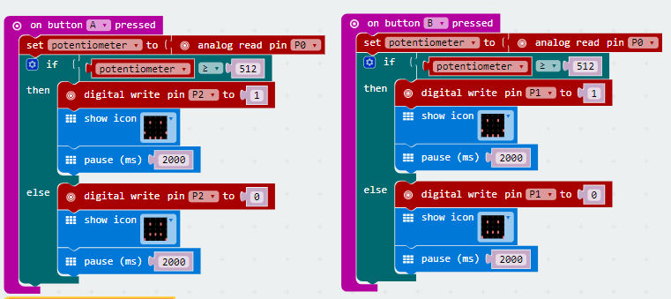

The final addition to the code blocks below look for press of button A + B and then execute a combined set of actions previously used to trigger both the Red, Blue and the Green filament simultaneously.

Try clicking in button A + B simultaneously and see what colour does the RGB LED light up as.

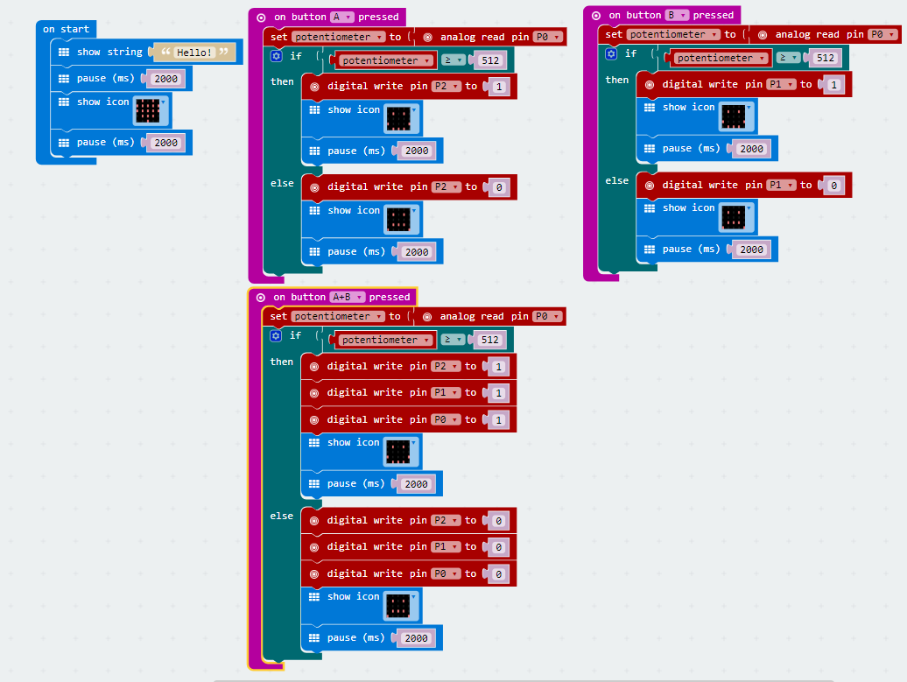

We encourage you to play around with the code, try increasing/decreasing the value of the pause time including changing the LED patterns displayed.

# Downloading Your Code To The micro:bit

Once you have completed the program, enter a name for your program using the option provided below i.e. in the text box adjacent to the small save button.



Now that you have given your program a name and saved it you can download it your micro:bit. But before we do that let’s confirm what drive your micro:bit shows up as. On most machines the micro:bit will show up as an additional USB drive. So head over into windows explorer and confirm what drive name (D:, E:, F:. G:, etc. ) the micro:bit shows up as. You need to absolutely be sure what drive the micro:bit shows up as. Once you’ve confirmed what drive the micro:bit shows up as on your machine you can select the right drive when downloading the code to the micro:bit. If in doubt please ask the volunteer/mentor/session facilitator helping out.



To download the newly written code to the micro:bit, hit the download button shown above. You should now see a dialog box open up and you will be asked to save the file somewhere on your machine. Please choose the drive your micro:bit shows up as i.e. D: or E: or F: or whatever it shows up as on your machine. A sign of success is when you see the lights on the rear (orange) lighting up in quick succession suggesting that the code is being written to the micro:bit. On completion the micro:bit reboots and you should now see the code in action on the micro:bit.

If hitting the download button shown above does not open up a dialog box asking you to save to the micro:bit please save the file (you will have a <filename.hex> file) to your desktop. Then open up windows explorer and drag that file onto the drive which is your micro:bit. A sign of success is when you see the lights on the rear (orange) lighting up in quick succession suggesting that the code is being written to the micro:bit. On completion the micro:bit reboots and you should now see the code in action on the micro:bit.

Please feel free to customize the code blocks, have a play. Add your own custom code and re-download the code to the micro:bit. Give yourself a tap on the back, you’ve just completed your first circuit!!!!!

# Challenges

Well done for completing the tutorial. There’s a lot of ground we have covered in this tutorial so please feel free to make notes, come back to the tutorial at some point down the line and ask your learning facilitator any questions or doubts you might have on the concepts covered this far.

For those who want to stretch it a bit further -

1. Add a 500ms delay between each of the “digital write” statements in the “A+B” button block and see how each of the Red, Blue, Green LED’s now light up independently one after the other with a very small delay.
2. Can you change the code above so that clicking A + B lights up the LED’s in one sequence i.e. red, green blue if the read analog value from the potentiometer is <512 and in another sequence if the analog value read from the potentiometer is > 512. Run this in an infinite loop.
3. Can you try changing the value of the pause commands to vary the time the LED’s are put to sleep?
4. Can you try different combinations of the pause commands to create an on/off lighting effect?